Dis-Eur-Crete-Snake Goddess

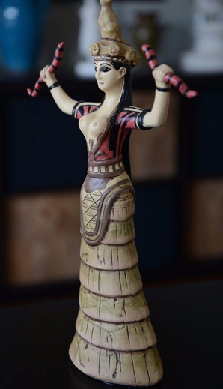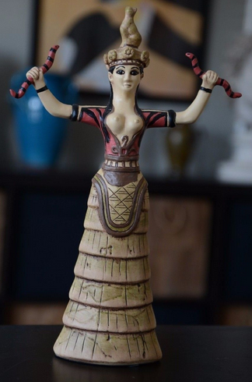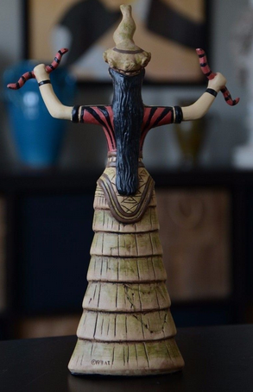

Cretan Minoan Snake Goddess of Knossos Statue Sculpture Replica Reproduction

Made of cast stone

Dimensions: 12"High (30.5 cm)

Weight: 3 lbs (1.4 kg)

Item No. 5082

Herakleion Museum, Crete, Greece

Period: pre-Hellenic (2800 - 800 B.C.)

Cretan Minoan Snake Goddess of Knossos Statue Sculpture Item No. 5082 Reproduced after the original from the Herakleion Museum, Crete, Greece. 1600 B.C. This figurine represents an agricultural fertility Goddess or her Priestess. The original was found in a storage room in the Palace of Knossos, Crete. She is a votive offering and not a cult figure and therefore, probably represents a Priestess who is perhaps a princess of the palace. Although she is dressed in the garb of her deity, a Cretan Earth Mother, she is a personification of Earth from which all life springs and returns. She carries the snakes, symbols of death and rebirth. Crouching on her crown is a lion cub, usually associated with royal houses. In her crown are poppy pods, indicating the use of opium in her worship.

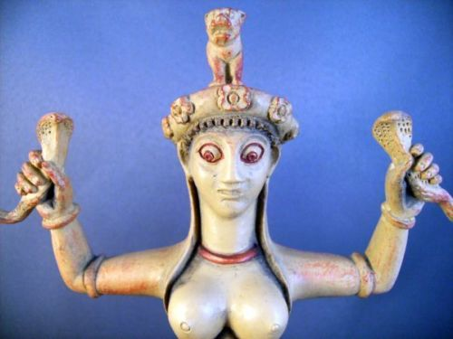 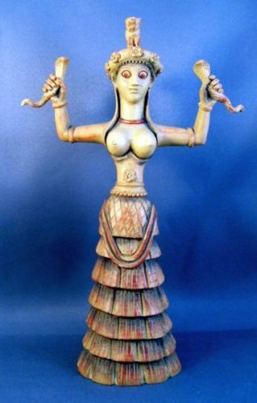 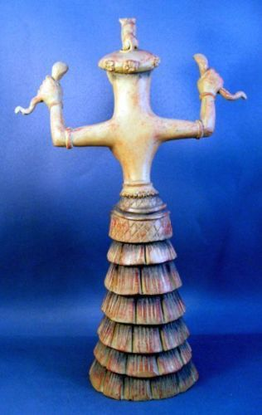

**Snake Goddess Ariadne Statue  
Goddess Ariadne Statue  
9 inches high gypsumstone statue, handpainted.   
  
Antiqued stone colored gypsumstone.**

**[Candia Museum, Crete,1600-1500 BCE]**

**Antiqued stone colored gypsumstone. Here the Goddess is adorned with her Cobra and Panther headdress as she holds the snake of rebirth and regeneration.**

**Goddess of Ecstatic Trance.  
Her priestesses, bare-breasted, practiced ritual snake handling, ecstatic dancing, and prophetic trance. Priestess-queens ruled Crete, the last culture in recorded history to support equality. Her staring gaze denotes an oracular role of this Goddess who appears to be in a trance with her snake companions.**

**GREEK ARIADNE  
"The High Fruitful One," brings Rebirth**

**This lunar fertility goddess was known for her athletic prowess. Serpents, symbols of rebirth, were ritually handled by her priestesses, whose bare-breasted costumes suggest the sacred role of sexuality in the Minoan culture.**

**Serpent Goddess promotes trance and dream time. The energy exuded by the snakes of this Cretan maiden exemplify sexuality, regeneration, and the mysterious otherworld of spirit journeying. Note her staring gaze and enigmatic inward smile, and if you choose, invite these "otherworldly" characteristics into your own meditations.**

**THE DELICATE SERPENT GODDESS (of Knossos) was discovered in the underground repository of the Second Palace of Knossos (1600 BCE] and was worshiped in Crete as early as 6000 BCE. She depicts the benevolence and sacred power of the Life Force, holding high the two serpents of immortality. The tiny panther or lion cub on her headdress may connect the goddess to the fertility rites of the wine god Dionysos or denote an altered state of consciousness.**

|  |  |
| --- | --- |
|  | http://i.ebayimg.com/images/g/YaIAAOSwa%7EBYXDAd/s-l1600.jpg  **Snake Goddess Ariadne Statue Goddess Ariadne Statue 8 3/4" gypsumstone statue, handpainted.   Antiqued stone colored gypsumstone. Here the Goddess is adorned with her Cobra headdress as she holds the snake of rebirth and regeneration.**  **[Candia Museum, Crete,1600-1500 BCE]**  **Goddess of Ecstatic Trance. Her priestesses, bare-breasted, practiced ritual snake handling, ecstatic dancing, and prophetic trance. Priestess-queens ruled Crete, the last culture in recorded history to support equality.**  **GREEK ARIADNE "The High Fruitful One," brings Rebirth**  **This lunar fertility goddess was known for her athletic prowess. Serpents, symbols of rebirth, were ritually handled by her priestesses, whose bare-breasted costumes suggest the sacred role of sexuality in the Minoan culture.**  **Serpent Goddess promotes trance and dream time. The energy exuded by the snakes of this Cretan maiden exemplify sexuality, regeneration, and the mysterious otherworld of spirit journeying. Note her staring gaze and enigmatic inward smile, and if you choose, invite these "otherworldly" characteristics into your own meditations.**  **THE DELICATE SERPENT GODDESS (of Knossos) was discovered in the underground repository of the Second Palace of Knossos (1600 BCE] and was worshiped in Crete as early as 6000 BCE. She depicts the benevolence and sacred power of the Life Force, holding high the two serpents of immortality.** |